USOSweb

Academic exchange

Instruction for students

# 1. Information

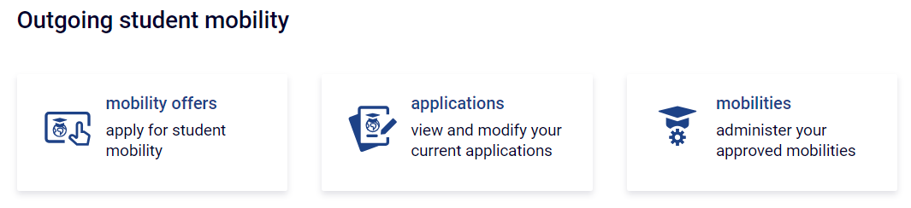All steps related to mobility under the Erasmus+ program take place in the FOR STUDENTS > STUDENT EXCHANGE > MOBILITY section.

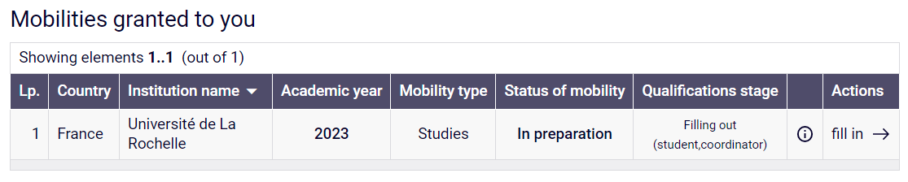When the faculty coordinator grants the mobility, click the button **„complete”** to give the necessary information for mobility.

Complete the declaration of previous mobilities and click **„save”**

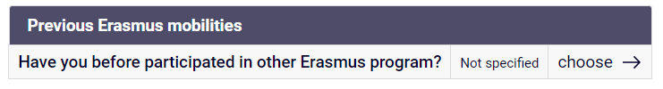Complete all the form and click **„save**

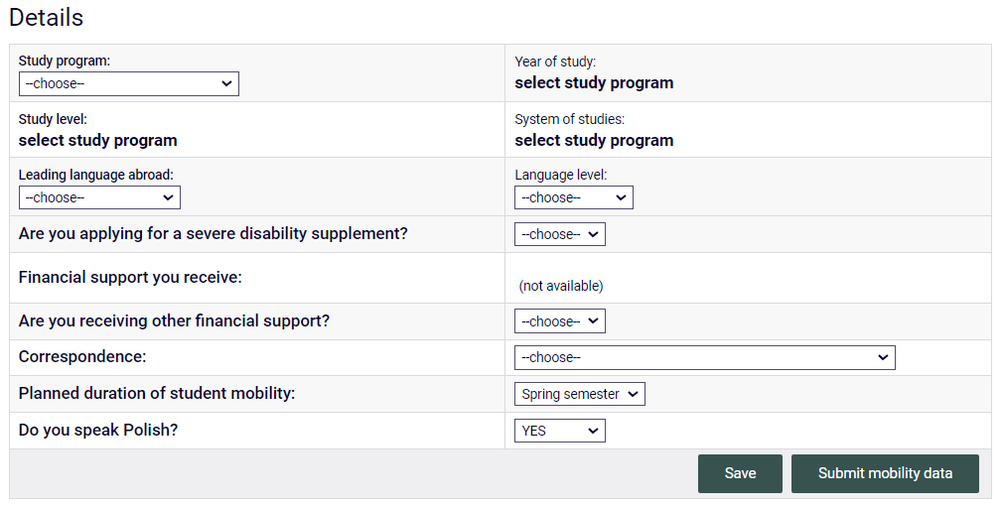

Inform the faculty coordinator that you have just completed the form.

The faculty coordinator will check the data you have entered and approve it.

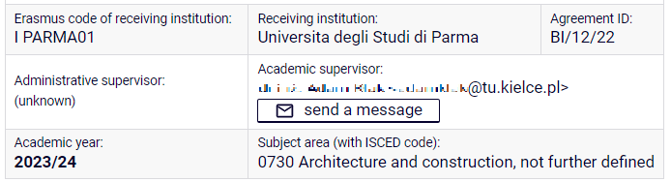**ATTENTION!** The system does not send notifications about changes in the mobility status at any stage. If you want to notify the coordinator about the changes, use the "**send message**" button in the mobility details table.

# 2. Learning Agreement (LA)

**2.1** After the first step of qualification, while you have the mobility granted in the system appear   
the link to „**EWP LA**”.

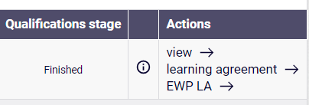

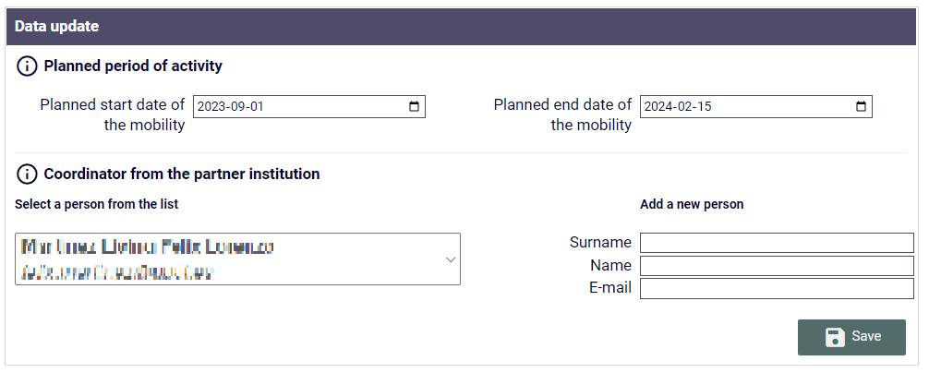Clicking on the link takes you to the form, where you need to fill in the information about   
the planned mobility period and the coordinator of the partner university. Saving the form also automatically generates an ESI.

**ATTENTION!** If after clicking on the "EWP LA" link appear an error message, it means that after the coordinator has approved the mobility, **the data migration between USOS   
and USOSweb** **has not yet taken place**. Data migration takes place at 6:00 a.m. and 3:00 p.m.

**2.2 The OLA creating**

* Once the data has been verified, the coordinator will create a Learning Agreement for your mobility.
* Click on the "EWP LA" link again. At the bottom of the form, you'll see the learning agreement.
* 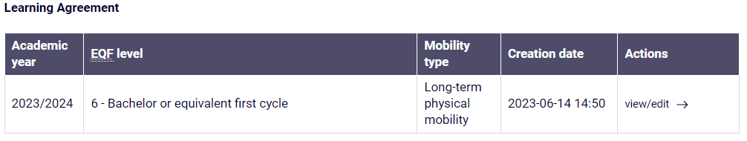Click on the "view/edit" link to go to the agreement table.
* Complete Table A based on the list of subjects offered by the host university.
* Complete Table B based on your study plan.

The form for completing table B allows you to search for items in the USOS catalog. Please note   
the correct item code. You can find the study plan and course codes   
in the "**CATALOGUE > Study Search" section.**

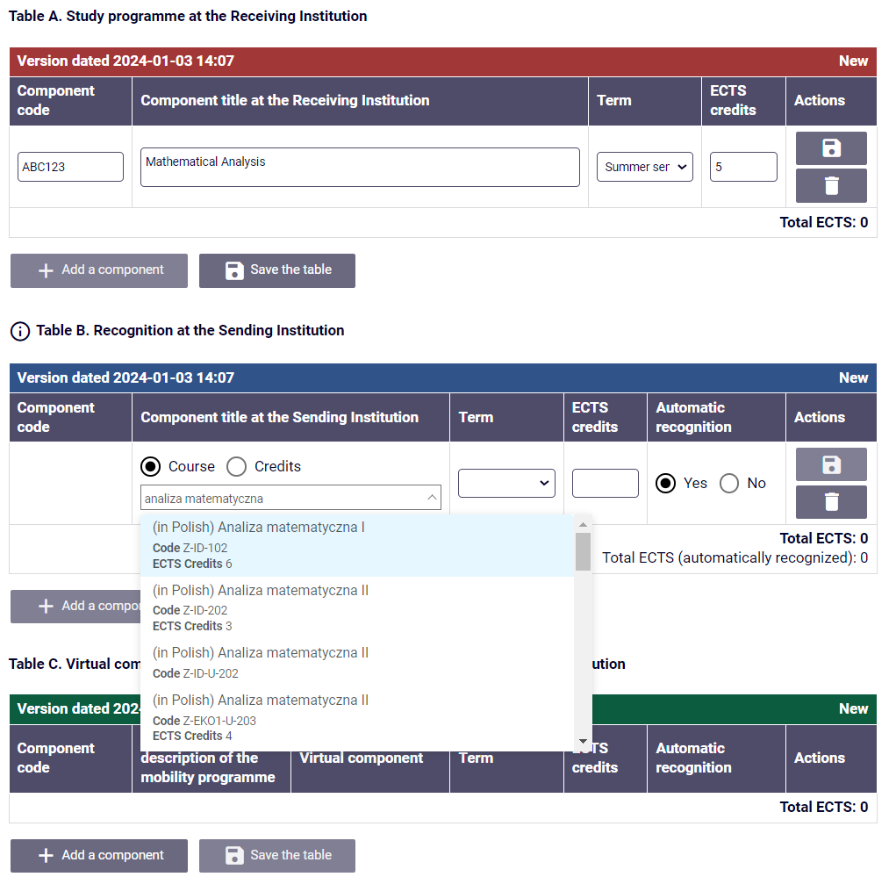

* Once you have completed and accepted the LA, inform the coordinator.
* The coordinator will verify and approve the data you provided.
* Once the agreement is accepted by you and the coordinator, it will be automatically sent to the partner university.
* If the agreement is rejected by the partner university, the coordinator will create a new version in which amendments must be made and accepted again.